WEEK 3

Step 1: Create Database and Collections
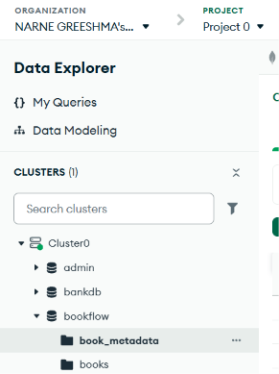
Step 2 : Insert Document
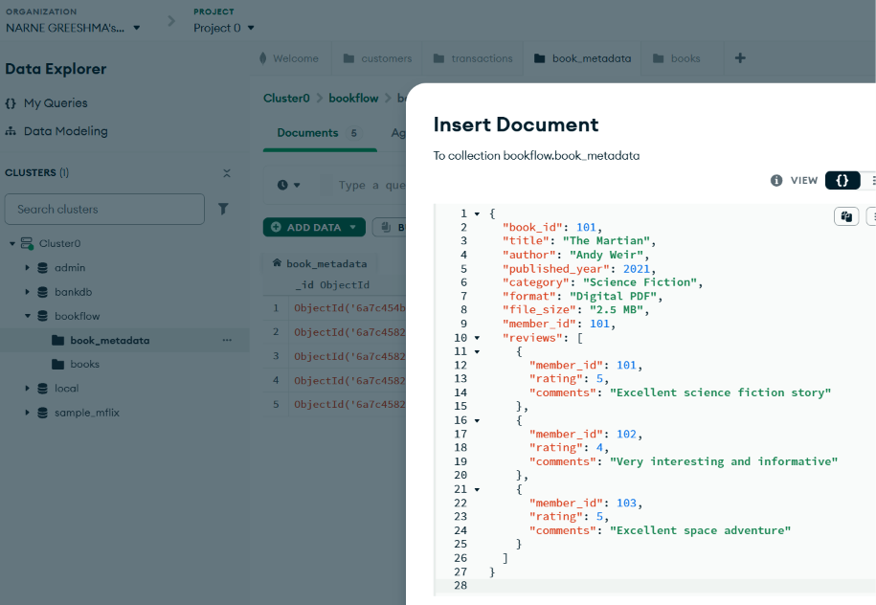
Step 3 : Verify Inserted Documents
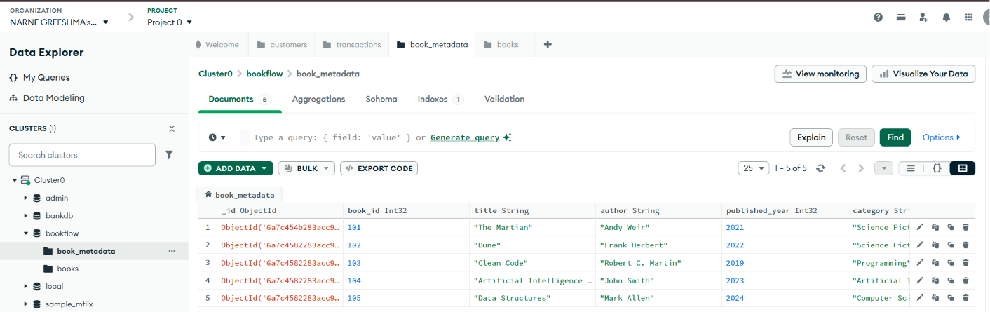
Step 4: Find Books Having Ratings Greater Than 4
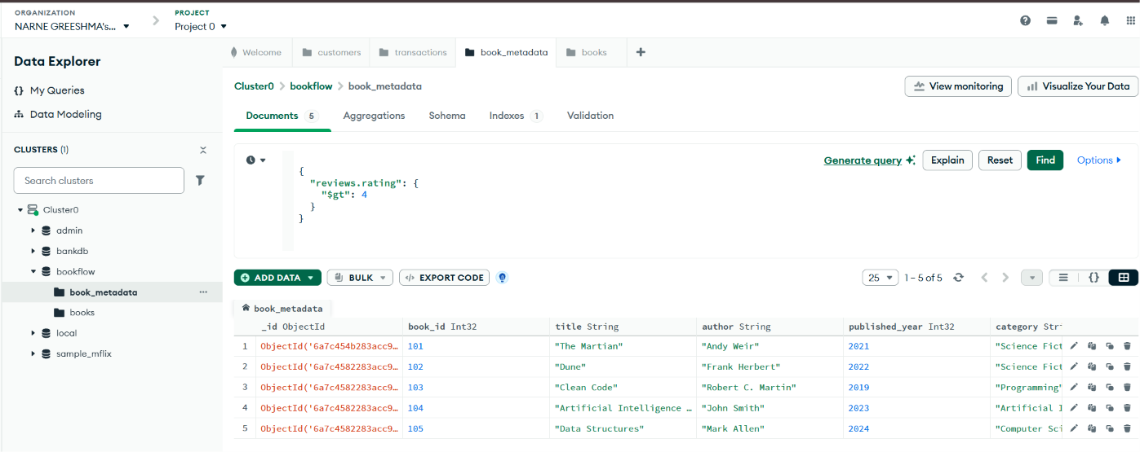
Step 5: Find books containing reviews with ratings 4 or 5
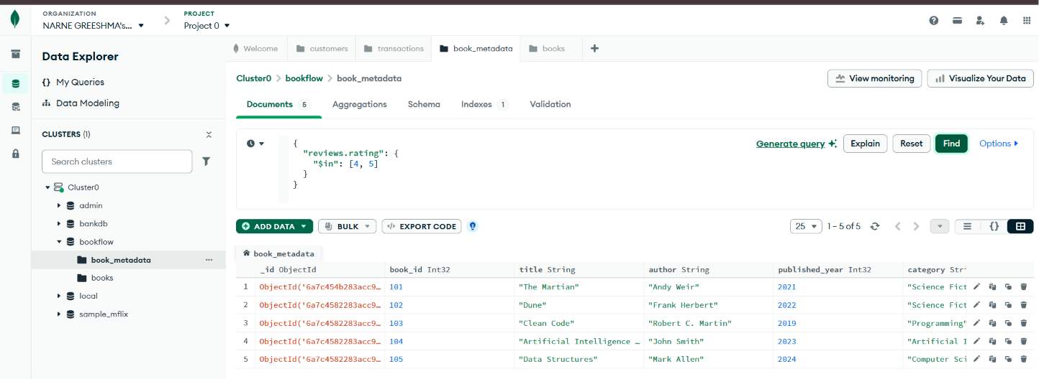

Step 6: Find books where the format contains the word: Digital

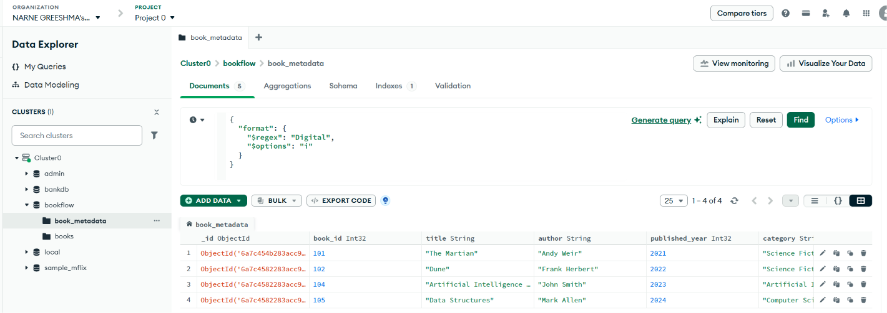
Step 7:
